INDEX

- Purpose
- Scope
- Reference documents/Standards
- Responsibility
- Procedures
- Records
- Revision Status

 | NAME | DESIGNATION | SIGNATURE | DATE
Prepared by | S. B. Nivetha | Quality & Regulatory engineer |  | 27/05/2025
Reviewed by | Dr. R. Prakash Rajiah | QA/RA Head |  | 27/05/2025
Approved by | Dr. A. Balaji Ganesh | Director/CEO | 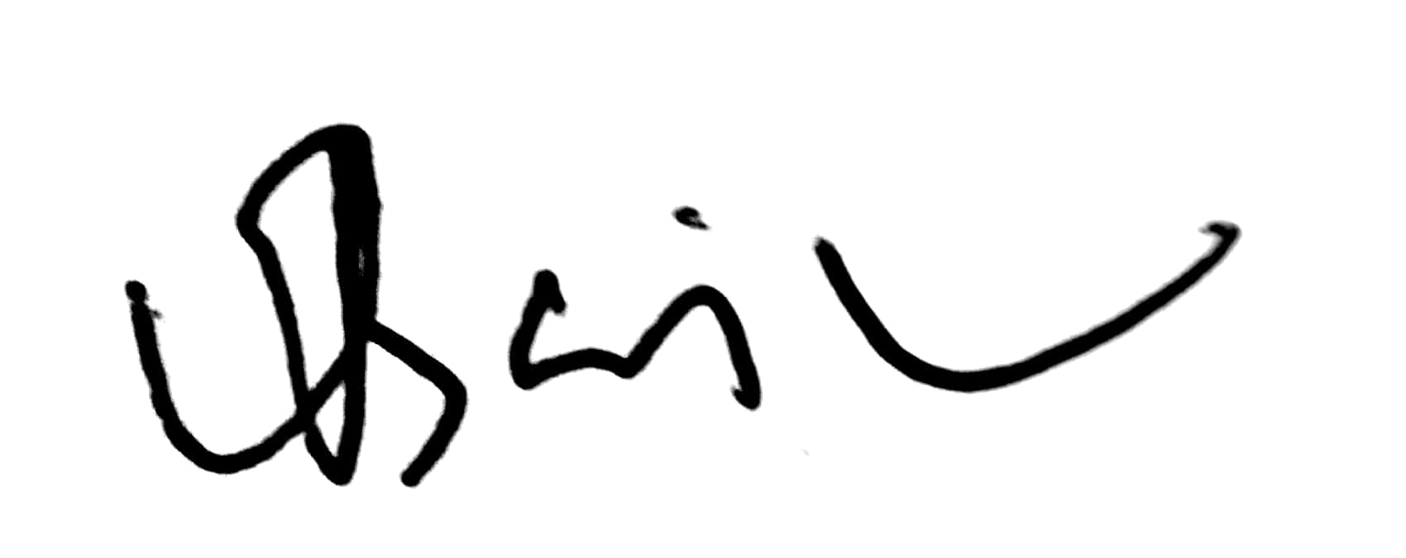 | 27/05/2025

- Purpose
The purpose of this procedure is to establish a structured and consistent approach to the design and development processes within Emsensing technologies private limited.

- Scope
The scope of this procedure is to ensure that all design and development activities are conducted efficiently and in compliance with relevant industry standards.
- Reference documents/standards
  - QMS Manual (ETPL/QM/00)
  - ISO 13485:2016 – Medical devices — Quality management systems — Requirements for regulatory purposes

- Responsibility
  - Hardware and software engineer
  - Director/CEO
  - QA/RA Head

- Procedure
  - Design and development planning
    - After the design is transferred from R & D department using Design transfer form (ETPL/F/70), the design plan that is carried out during the process and are documented in Design and development planning format (ETPL/F/73)
- Architecture design (EMI/EMC compliance) designed to monitor/Control the fluid flow for the patients through IV tube
- Respective Schematic/ Layout/PCB Design is planned to be carried out for the dripset to achieve the objective of the product
- Associated Firmware Integration and Testing is planned to be carried out in an effective manner to in order to achieve the desired reliability

 | NAME | DESIGNATION | SIGNATURE | DATE
Reviewed by | Dr. R. Prakash Rajiah | QA/RA Head |  | 05/07/2024
Approved by | Dr. A. Balaji Ganesh | Director/CEO |  | 05/07/2024

  - Design input
Design input form (ETPL/F/71)
- If the desired flow rate is higher than the real time flow, then the tube is compressed to compensate for the additional flow.
- If the desired flow rate is higher than the real time flow, then the tube is compressed to compensate for the additional flow
- The tube is compressed to the maximum level so that there is no flow both in forward and backward in the following conditions:
- If the fluid is not flowing
- If the saline bottle is empty
- If there is any clog in the tube
- If the desired amount of saline has been infused
- If the set amount of time has elapsed
- If the battery level is below 5 percent

- The port is opened to its maximum in the following condition:
When the device is started initially to place the iv tube. When the release button is pressed in the app
- The device should have a motor that can control the increment counter from 1mL/hr–16 mL/hr
- The device motor should configure to have an infused Volume selector (VTBI) from 100 to 1000 mL
- The device motor should have a configured to pause the infusion facility
- The device IR transmitter/ receiver raises a fault if there is a free flow detected and close the motor
- The device should have an OLED to display the real time data, the font should be large and easy to display with easy setup option
- The RF frequency sweep should be within the range of 80MHz to 1GHz with an amplitude modulation of 80% on 1KHz signal.
- Flow rate Reliability should be 99.
- Device Should Weight around 0.5Kg
- Device should sit on the clamp support when placing on the IV tube
- EMC/EMI compliance support
- Fault management should be in Place with different error codes
- Device should indicate No flow detection and stop the infusion when IR fails to work
- The device should indicate overflow detection with an alarm when the Hall sensor or motor malfunctions.
- The device should automatically switch to offline mode with current flow rate when the Wi-Fi connection is lost while operating in remote mode.
- In the event of an any error, the device should stop the infusion process and indicate with alarm
- If the Bubble sensor malfunctions while turning on the device, the device shouldn't proceed with the process.
- If bubble sensor failed in running mode, Device should indicate the bubble failure and stop the infusion
- Approval for testing the devices
- Approval for manufacturing the device

  - Design output and review
Design output and review form (ETPL/F/72)
    - All design inputs shall be reviewed and satisfied with the requirements.
    - All the test readings that are taken to check/verify/validate the specification, shall be controlled as ETPL/TR/00 where ETPL-Company name, TR-Test Reading, 00-serial number.

  - Design and development review
Design output and review form (ETPL/F/72)
    - Throughout the design process, design and development team meets to review the following:
- Initial design concept
- Review of previous design version
- Design input
- Testing requirement
- Design changes
- Challenges during production

    - The review must be captured and documented.

    - The decision of the review must be documented as part of the Device History File (ETPL/DHF/00)

    - The stages of the design shall be maintained in the Design Stages document (ETPL/DS/00) where ETPL-Company name, DS-Design Stages, 00-Serial number.

Topic | Discussion Topics | Follow up Action | Committee Members | Review Intervals
Initial design  Concept | Design Input is clearly explained. Device Motor specification requirement is sent | Design input is converted into technical specification | Dr. R. Prakash Rajiah  QA/RA Head  Dr. A. Balaji Ganesh Director/CEO | 3 Months
Review of design | Initial design is ready and waiting for approval | Design changes have been amended | Dr.R. Prakash Rajiah  QA/RA Head  Dr.A.Balaji Ganesh Director/CEO | 3 Months
Testing requirement for design | Production line testing  Software testing | Challenges during production line testing  Relevant delays in software testing | Dr.R. Prakash Rajiah  QA/RA Head  Dr.A.Balaji Ganesh Director/CEO | 5 Months

  - Design and development verification
Design verification format (ETPL/F/78)
    - All parameters identified in the design input are tested to ensure they are met by the design outputs.
    - The Hardware and software engineer who performs the testing must document when the testing was performed, what methods were used, and the results.
    - Each device undergoes multiple tests under different scenarios and must pass all the tests carried out by the Hardware and software engineer.
  - Verification plans for design and development
    - List of Verification plan that is verified during the process:
- Flow rate to 200 ml/hr.
- Increment counter to 5 ml/hr.
- Volume to be infused selector is set to 200ml
- Pause infusion facility
- Free flow protection
- Air Bubble detection
- OLED test
    - The above requirements will be verified for each product production process. The verification process will be followed as per the design verification section. The design verification will be verified and documented in the Design verification form (ETPL/F/78) by the Emsense team.

  - Arrangements for design and development validation

    - The validation process arrangements that include the following:
- The assembled motor is arranged in the correct place on the dripset.
- Make sure that motor placement is rigid and tight in place
- IR transmitter/receiver is arranged in the correct place on the dripset
- Make sure the IR transmitter/receiver able to detect the transmitted signals back

  - Validation plans for design and development
    - The dripset device is validated in such a way that the user needs are met with the final device. The design input/output is matched with below validation remarks and documented in Design validation form (ETPL/F/75)

Type of Test | Total Quantity (ml) | Status | Remarks
Stepper Motor Open | 100 | Pass | Motor Opened correctly
Stepper Motor Closing | 100 | Pass | Motor Closed correctly
Stepper Motor Hold | 100 | Pass | Motor Hold the tube at desired rate
Infusion pause/stop | 100 | Pass | Infusion pause/stop
Air Bubble Detection | 100 | Pass | Air bubble is simulated and detected
OLED test | 100 | Pass | OLED display clear and easy with real time plot

  - Design Transfer
    - A design transfer meeting shall be conducted with R&D, QA/RA, and manufacturing head to review the readiness of the design files and for the purpose of knowledge transfer.
    - The following documents shall be completed, approved and transferred:
- Product specifications and drawings (mechanical, electrical, software)
- Bill of Materials (BOM) for approved components and materials
- Design input, output, verification and validation data
- Test protocols and acceptance criteria data
- Firmware files
    - The design transfer documents shall be controlled as ETPL/DTD/00, where ETPL - Company name; DTD - Design Transfer Document; 00 - Serial number
    - The manufacturing head shall review the transferred documents and proceed with the production plan.

  - Procedure to control design and development changes
    - The design change will be carried out by the design change process.

    - The design change meeting will be scheduled with the Director/CEO, QA/RA, and manufacturing head from the Emsense and technical team from the vendor.

    - The relevant design changes will be followed by design life cycle and documented in Design changes form (ETPL/F/74)

- Records
  - Design transfer form (ETPL/F/70)
  - Design input (ETPL/F/71)
  - Design output and review (ETPL/F/72)
  - Design and development planning (ETPL/F/73)
  - Design changes (ETPL/F/74)
  - Design validation (ETPL/F/75)
  - Design verification form (ETPL/F/78)

- Revision status
Section No. | Previous  Rev. No. &  Effective Date | Current  Rev. No. & Effective Date | Reason for revision | Reviewed by Signature
5.9 | 00 & 01/03/2024 | 01 & 27/05/2025 | Added design transfer part

